Uniform Guide – July 2026
Reception to Year 5

Navy polo shirt | 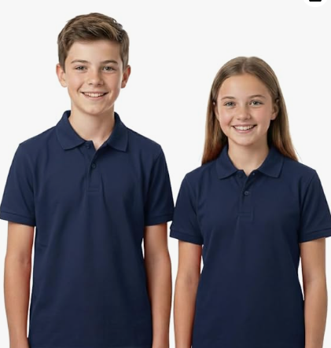 |  | Grey skirt |  | 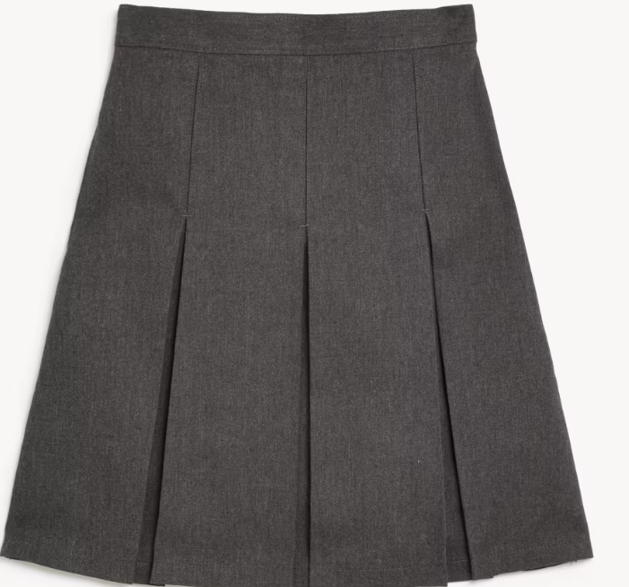 | Summer dress  Summer term and first half of Autumn term only (optional) |  | 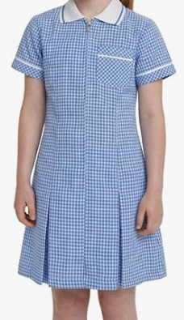
Grey trousers |  | 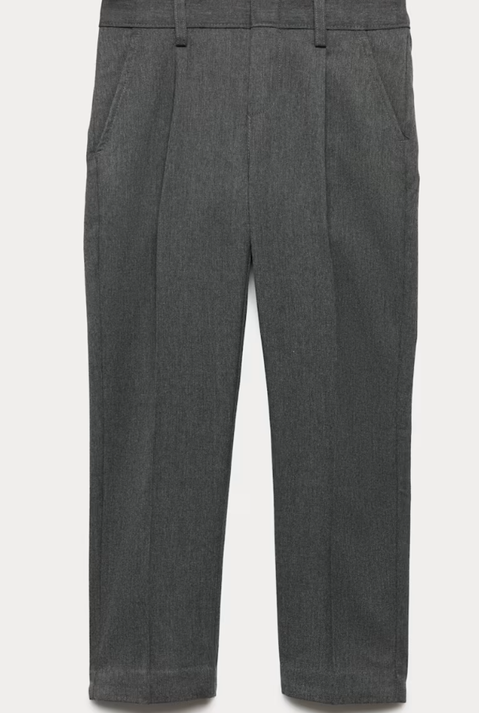 |  | Grey socks |  |  | 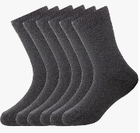
 |  |  |  | Grey tights |  |  | 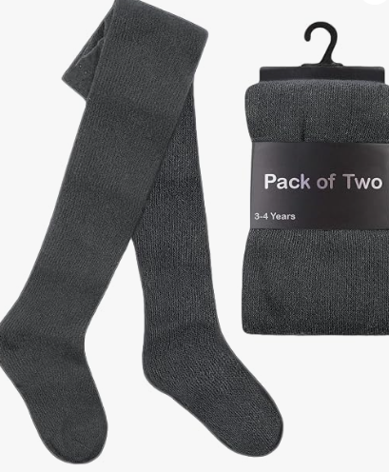
Black school shoes |  | 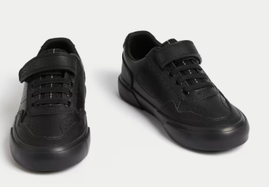 |  | Black trainers – no other colours at all |  |  | 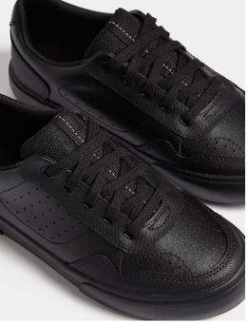
School jumper  Branded with logo |  | 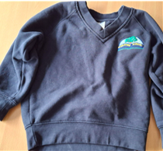 |  | School cardigan  Branded with logo |  |  | 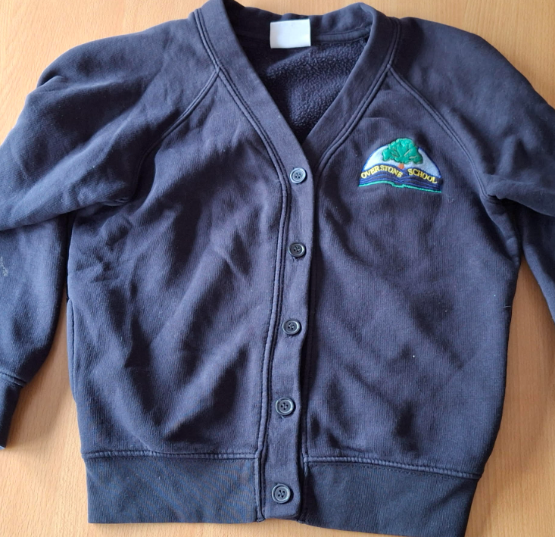
PE shirt |  | 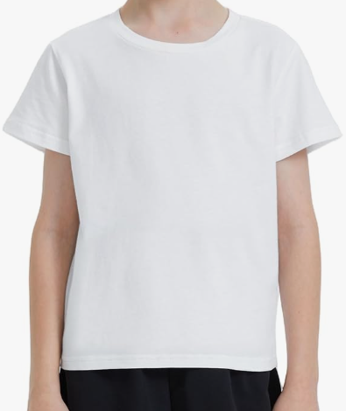 |  | PE shorts  NOT CYCLING SHORTS |  |  | 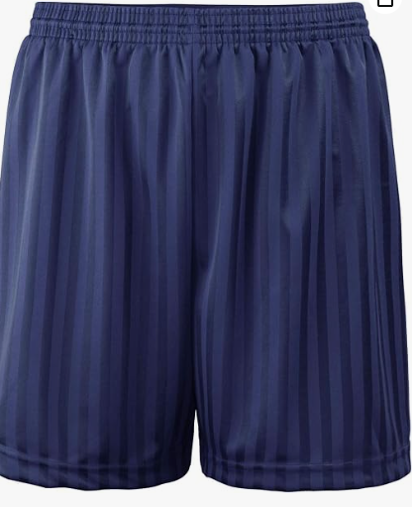
Tracksuit  NO LEGGINGS  SWEATSHIRT ONLY - NO HOODIES |  | 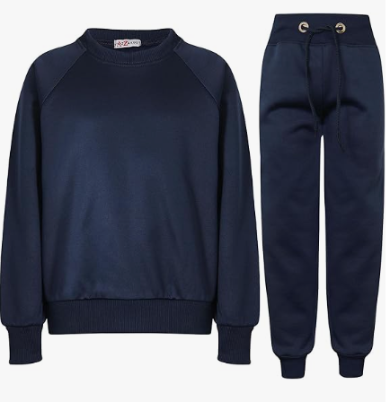 |  | Trainers |  |  | 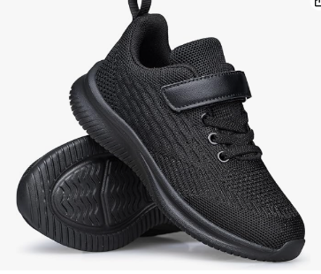
Year 6
White school shirt – Year 6 only |  | 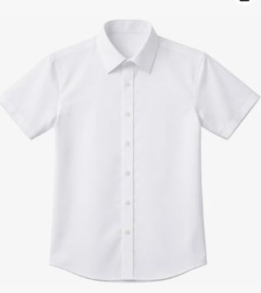 |  | School tie – Year 6 only  Clip on and tie versions are both acceptable |  |  | 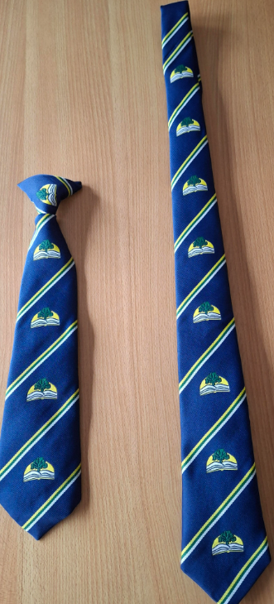
Grey trousers |  |  |  | Grey socks |  |  | 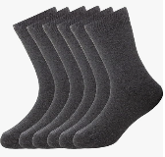
 |  |  |  | Grey tights
Grey skirt |  |  |  | Black school shoes |  |  | 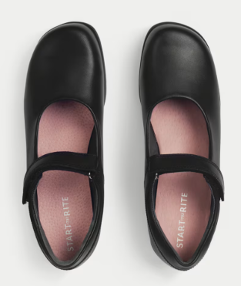
 |  |  |  | Black trainers – no other colours at all |  |  | 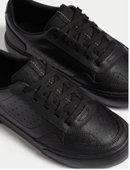
School jumper  Branded with logo |  | 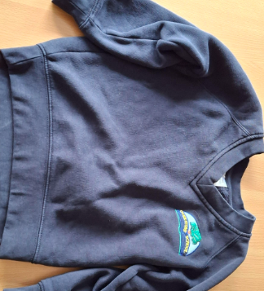 |  | School cardigan  Branded with logo |  |  | 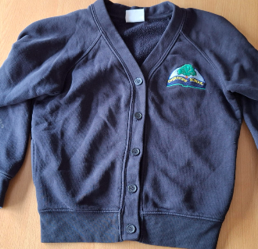
PE shirt |  |  |  | PE shorts  NOT CYCLING SHORTS
Tracksuit  NO LEGGINGS  SWEATSHIRT ONLY - NO HOODIES |  |  |  | Trainers

